GHTC webinar:

Health innovation in the post-2015 agenda

Summary report

Introduction
The Global Health Technologies Coalition (GHTC) is hosting a series of webinars to inform and engage global health stakeholders, including both product developers and advocates. Each webinar focuses on a topic critical to global health research and development (R&D) and is designed to provide balanced information that draws from diverse perspectives.
On April 28, 2015, GHTC held a webinar to explore the role of health innovation in the United Nations (UN) post-2015 development agenda facilitated by Mitchell Warren, Executive Director of AVAC. Webinar panelists included:
- Jenna Slotin, Deputy Director, Post-2015 Initiative, UN Foundation
- Dr. Nick Chapman, Director of Research, Policy Cures
- Dr. Genevieve Maricle, Policy Adviser to US Ambassador (ECOSOC), US Mission to the UN
- Willo Brock, Senior Vice President of External Affairs, TB Alliance
This document provides summaries of each panelist’s opening presentation, as well as syntheses of panelists’ responses to audience questions. Additional questions submitted by audience members and audience members’ feedback on the webinar are provided in Appendices A and B.

Panel presentations

The post-2015 development agenda

Jenna Slotin, UN Foundation

Overview of the post-2015 development agenda
The post-2015 development agenda will outline development goals for the world to meet between 2015 and 2030. The United Nations General Assembly (UNGA) member states agreed that the agenda will include the following:
- The Declaration: Overall vision of where they want the world to be in 2030.
- Goals and Targets: Sustainable Development Goals (SDGs) with corresponding targets that build on the Millennium Development Goals (MDGs).
- Financing and Means of Implementation: Outline of who will finance the work, how it will be implemented, and policy plans for meeting development goals.
- Monitoring and Accountability: Methods to review progress and hold actors accountable to their commitments.
In July 2013, an Open Working Group (OWG) of the UNGA proposed 17 goals and 169 targets as the SDGs (Figure 1). These goals—which relate to world poverty, health, education, inequality, and environmental health—have three distinct qualities that differentiate them from the MDGs:
- Inclusive: To help define the SDGs, the OWG obtained input from more than five million people via an online survey (My World 2015), from hundreds of consultations held by the UN and nongovernmental organizations (NGOs) worldwide, and from a range of other avenues through which civil society and other stakeholders fed into the process. Additionally, every UN member state has had a chance to be a part of defining and negotiating the SDGs.
- Transformative: Unlike the MDGs, the SDGs directly address inequality (i.e., ensuring that growth is inclusive and shared by all countries and peoples) and sustainability (i.e., pursuing economic growth in a way that protects our planet and ecosystems).
- Universal: The SDGs are intended to apply to all countries, while the MDGs mostly applied to developing countries.
Figure 1. Processes feeding in the post-2015 development agenda
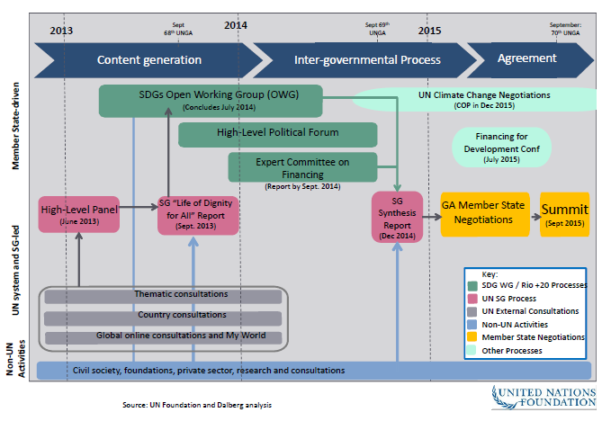

Current work in developing the agenda
UN member states are scheduled to approve the SDGs in September 2015 at UNGA, and the goals and targets are not expected to substantially change between now and then. Ongoing debates revolve around financing and implementing the goals, streamlining the SDGs to be more engaging without losing the delicate political balance that they currently capture, and defining indicators and a long-term monitoring and accountability process—a discussion that is likely to continue through March 2016. To help facilitate the finalization of the SDGs, the UN foundation will continue to serve as a resource and intellectual partner, help build consensus among UNGA member states, and connect other stakeholders to the UN process.

Measuring innovation for global health in the post-2015 development agenda

Dr. Nick Chapman, Policy Cures

The need for health innovation indicators
Out of the 19 SDG targets identified as having the highest potential impact per dollar spent, eight involve health (e.g., reducing tuberculosis (TB), malaria, HIV, and maternal/child/neonatal mortality). Health technology innovation, such as new drugs and diagnostic tools, is critical to achieving these targets in the set timeframe; yet, it is barely mentioned in the SDGs. In fact, only one of the 169 targets mentions health innovation, and it is in combination with improving access to these tools, despite innovation and access being two distinct elements that need different solutions as well as different ways of being measured.
The global health R&D needed to achieve the SDGs will not happen automatically and will rely heavily on government funding and philanthropy, due to a lack of any incentive for private sector investment in these disease areas. To motivate these potential funders and ensure that there is a way to measure progress for global health R&D, robust indicators for health innovation need to be included in the post-2015 agenda.

Potential barriers
Health innovation indicators aren’t currently included in proposed indicators for the post-2015 agenda. Indicators that have been proposed to date—including those from the UN Statistical Commission, the World Health Organization (WHO), and the Sustainable Development Solutions Network—do not specifically mention global health innovation or R&D as required indicators.
There is limited opportunity to add additional indicators to the agenda. The universal consensus is that each state government can only reliably measure 120 indicators, which leaves room for less than one indicator per target and will result in the need to adopt cross-cutting indicators that can measure multiple targets.
Few indicators that measure health innovation currently exist. While there are many known indicators that measure health or that measure innovation, there are few established indicators that specifically measure health innovation (Figure 2).
Figure 2. Indicators that measure health innovation
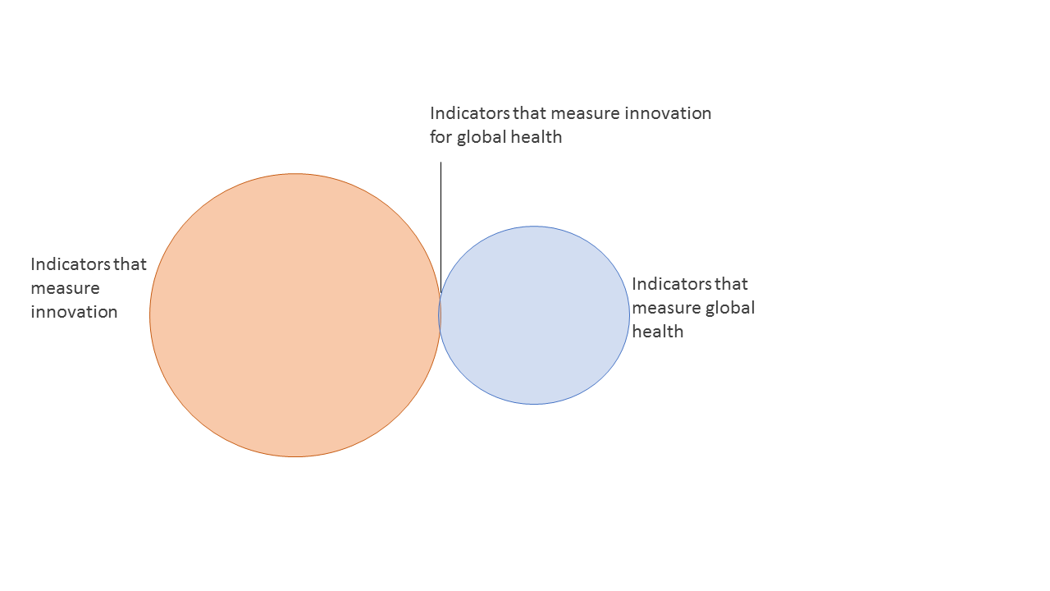
Courtesy of Dr. Nick Chapman, Policy Cures

The path forward
Policy Cures is currently working to identify a small number of health R&D indicators that could be included in the SDG global monitoring framework. They are striving for a balance between realism and aspiration to find indicators that are feasible, suitable, and relevant to targets in the post-2015 agenda, but that are not constrained by traditional measurements and methodologies.

The US perspective on developing and implementing the post-2015 agenda

Dr. Genevieve Maricle, US Mission to the UN

The US process for shaping the SDGs
One of the key lessons learned from the MDGs is that the clarity and precision of the goals were what gave them a unifying force. However, there were also many gaps in the MDGs that resulted in an uneven achievement of what they had originally set out to do. From the perspective of the US government, the overarching goal in defining the SDGs was to address the wide range of development issues more comprehensively than the MDGs while maintaining their clarity and their focus on reaching the bottom quintile of the population.
The United States conducted a robust, evidence-based process to clearly define its SDG priorities engaging the highest levels of US government from the beginning. In initially defining these priorities and as negotiations continue, the United States is committed to:
- Continuing the unfinished work of the MDGs. The MDGs set the global health community on a path of remarkable and sustained progress. Continuing the MDGs’ work in specific topic areas and maintaining the MDGs’ overall approach is critical to sustaining their momentum.
- Including transformative issues that were previously missing from the MDGs. There were a lot of critical issues missing from the MDGs, such as gender equality, women’s empowerment, job-rich growth, peace and governance, and environmental sustainability. The SDGs need to pull these issues together in a cohesive way.

Implementing the SDGs
Ultimately, the success of the post-2015 agenda hinges on the strength of its implementation within and across nations. Health innovation will be a critical tool in the implementation of the agenda, but it needs to be codified and nurtured in order to be successful. Specifically mentioning R&D and innovation in the SDG targets and indicators or connecting a new network of innovators to compel the work forward, among other ideas, could help drive this innovation forward.
One of the ways the US government—in collaboration with Grand Challenges Canada, the Bill & Melinda Gates Foundation, and others—has fostered innovation is through the Grand Challenges program. This program identifies key health problems, sends out a worldwide call for ideas that offers a way for any person with any background to submit their innovative solutions for addressing the problems, and reviews the submitted ideas to identify the best ones and scale them up.

For example, the Saving Lives at Birth Grand Challenges Program received 2,000 applications from 102 different countries. One award recipient was a car mechanic from Argentina who, inspired by a party trick, developed a device for obstructed labor.
The post-2015 development agenda should be about finding, elevating, and sharing these kinds of ideas around the world so that everyone benefits from progress made in one area. The implementation of the agenda as well as the monitoring and review process can aid in connecting people and sharing ideas and solutions globally in this way.

Why the SDGs matter for global health product developers

Willo Brock, TB Alliance

Background of the TB Alliance
The TB Alliance was founded alongside the MDGs in an effort to leverage public-private partnerships to develop new global health products. Its founders realized that the MDG TB goals could not be achieved without new tools and believed public-private partnerships were the most effective way to develop them. Since its inception, TB Alliance has developed the largest pipeline of new potential TB drugs and has become part of a network of international organizations addressing TB issues.

TB Alliance engagement in the SDGs
The TB Alliance is involved with the SDGs because the SDGs will ultimately be what every development organization focuses on. Any organization involved in international development will have to engage with the SDGs, because if an objective is not part of that agenda, it’s unlikely to be achieved at any magnitude.
The SDGs aim for everyone to have the same quality of health treatment and health outcomes, regardless of where they live in the world—the concept of convergence. In order for this goal to be met for TB, there must be a 95% reduction in the TB mortality rate and 90% reduction in incidence.

To reach these goals, there must be a dramatic change in the way TB treatment works today. While there has been significant progress over the past 15 years—a two percent annual reduction in TB incidence globally—the SDG goals cannot be met for TB without innovation and new tools and treatments

The need for TB treatment innovation
Today’s TB treatment regimens are long and difficult for individuals to complete, and they put a great deal of pressure on local health systems to monitor patients’ adherence to the treatments. Developing treatments that are shorter, easier to administer, and that enable patients to continue to live their lives as they normally would are important areas for innovation.
There are currently no TB medications that are in an appropriate dosage for children. Parents must cut TB pills to the appropriate dose for their children, and they must do so reliably multiple times a day for months. TB Alliance is working with partner organizations to develop a dissolvable pill so that children receive the right dose and the medication is easier to administer.
There is also a need for improved treatments for adults. One-third of HIV/AIDS patients are co-infected with TB, and 5 percent of all patients that contract TB have a drug-resistant strain. A patient with TB must take four pills a day for six months, while a patient with HIV/AIDS and a drug-resistant strain of TB must take dozens of pills a day for 18 to 24 months. In addition, 75 percent of people who contract TB will stop their productive economic activities, so even if they survive the infection, they may be thrown into a crippling cycle of poverty. Innovation has the potential to not only make treatments easier for patients, but to ultimately reduce poverty levels.
The world has set health goals that are ambitious but logical; a lot of people will support them. However, despite being generally comprehensive, the process to develop the goals and indicators has neglected research and innovation for health. Regardless of how many indicators or targets there are, research and innovation need to be prioritized in the post-2015 agenda in order to achieve the envisioned health impact.

Questions and discussion
Q: One of the realities of target setting is that the targets have to be measurable and actionable, but we also need the resources to achieve them. Have we determined how much it would cost to achieve all of this work? If not, then why not?
A: Finance experts have defined rough orders of magnitude of certain costs; their report is available on the UN Sustainable Development website. However, the report does not contain any overall hard costs, as it is incredibly difficult to cost out this type of work, particularly regarding innovation. Future changes could dramatically increase or decrease costs in ways that cannot be predicted today.
A report has looked at the projected costs of monitoring the agenda and found these costs to be extremely high. For TB in particular, experts estimate that it will cost about one billion dollars to get a six-week TB treatment on the market. While these numbers may seem high, they are on the order of what pharmaceutical companies spend on hundreds of new treatments every year, and many countries have already committed investments to this issue area.

Rather than focusing only on projected overall cost, it is also important to think about the different sources of funding and types of financing mechanisms that could be developed. A focus on experimenting and innovating with different types of financing will ultimately enable the achievement of the SDGs and avoid the stasis that comes from just looking at hard costs.
When thinking about financing the agenda, the world needs to look beyond traditional aid—considering domestic tax revenues, debt relief, public-private partnerships, and loans—and also find ways to use existing funding more efficiently. It is also important to foster broad-based investment, particularly in research and innovation, that draws on the resources of all countries (proportionally to their income), rather than relying predominantly on investment from the United States and other traditional donor countries.
Q: Once the post-2015 agenda is codified, is there an implementation vision for helping countries develop the policies they need to achieve the agenda?
A: In March during the intergovernmental negotiations, a panel was held with implementers discussing what they are already doing to translate the agenda into national development plans. It has been inspiring to see how much people from around the world have already mobilized around creating an effective policy space for implementing the post-2015 agenda.
Despite this progress, there are still very real needs. Part of the conversation at the International Conference on Financing for Development in July 2015 will focus on what policies are needed to enable innovation, and what kind of changes will be needed to achieve that environment. Ultimately, what will be put down on paper will be a small window into what needs to be done to achieve the agenda.
Q: Do you have insight into the recent discussions around technology transfer and how this fits into post-2015 and financing for development?
A: At the moment, conversations about technology transfer tend to happen separately between countries’ capitals and at the UN in New York. There is a strong focus on trying to bring those different conversations together, but there is not a clear decision on where the technology transfer discussion will fall within the ongoing negotiations. There will definitely be a conversation about science and technology in the Financing for Development Conference, and most likely the conversation will continue in the discussions of post-2015 agenda implementation.
In addition, there is general disagreement between developed and developing countries about where the conversations around technology transfer should go, and the conversations don’t yet engage all of the relevant actors. The conversations tend to be driven by government agencies, when really this innovation will require partnerships between private businesses, academia, governments, and nonprofits. There needs to be a focus on building those relationships and on feeding all of those voices into the ongoing discussions.
Q: How do we keep civil society engaged in this overall process, not just for the next six months but for the next 15 years? And who do they hold accountable at the national, subnational, or global level?
A: By having an inclusive process from the beginning of this work, the global community has built an awareness of the agenda and created an opportunity for people to buy in to that work. Global and local campaign groups have done a lot to make sure everyone is familiar with the agenda, so that they know their governments have agreed to it and that they have a right to hold their governments accountable to that agenda. Ultimately, governments should not only be held accountable at the UN in New York every few years, but also on a regular basis by their people.
Q: Who owns this work after 2015?
A: Everyone does. This agenda will be equally challenging for countries at all levels of development around the world, which means everyone will have to engage with the agenda in some way. While for some organizations this will mean taking on just one item of the agenda, for others it will simply mean linking their efforts to the SDGs and articulating how their work advanced those priorities. In addition, there is a global campaign underway called Action 2015 that is teaching people about the agenda and engaging them in the agenda’s work. Launched in April in 60–70 countries, the campaign provides ways for global leaders to engage with 15 year-olds around the world in an effort to communicate that this agenda really is for everyone, including the next generation.
Q: What does 2020 look like? What will you look for to know that we’re on the right track to reach our goals for 2030?
A: Although there are many different ways to answer this question, broadly speaking, benchmarks could include:
- A broader base of domestic investment in research and innovation and more equitable sourcing of investment.
- A global platform/monitoring scheme for all stakeholders to define what progress looks like and to iterate on original trajectories
- A clear sense from all actors (government, pharmaceutical companies, private sector, public sector) of how they will do business differently (e.g., How will the UN support governments differently? How will governments support their people differently? How will businesses conduct their work differently?)
For specific health areas, benchmarks include:
- A new TB treatment that is about two months shorter than the current six-month treatment and appropriate for all drug sensitive patients and many drug resistant patients. .
- An outline of a treatment regimen that can be easily administered to all TB patients.
- Global availability and distribution of a children’s TB treatment.
- Broad adoption in developing countries of pre-exposure prophylaxis (PrEP) HIV/AIDS prevention method.
- Investment in R&D being followed by investment in product introduction.
Q: Innovation and R&D are not outlined as priorities in the goals and targets, but is there anything that leaders in the US government or others can do to help raise innovation in ongoing conversations so others are aware of its importance?
A: Members of the US government have focused on making innovation a major theme in the agenda’s implementation process. There could be an opportunity as well to incorporate it into the agenda’s political declaration. The political declaration is intended to communicate everything that the agenda is trying to achieve in a way that is understandable and engaging. Highlighting the role of innovation in the agenda’s work and providing examples of those opportunities would enable this clear communication and establish innovation as a guiding principle through all of the global health community’s work.
Q: Are there any changes that need to happen to our R&D infrastructure by 2018 or 2020, to enable the kind of innovation we need?
A: Public-private partnerships with a patient-centered approach have been very successful in creating a pipeline of new, effective technologies to meet the health needs of developing countries; however, many agree that some critical changes need to be made the overall R&D structure. It will be important to sustain and build cross-cutting partnerships between governments, companies, researchers, and other actors and consider end-user needs from the beginning because there are too many new technologies that do not meet the world’s or end users’ needs or are restricted to a single market.
Governments, intergovernmental organizations, and philanthropic organizations have started working together to change the R&D structure. One of the most exciting parts of this process is the rising leadership of the BRICS (Brazil, Russia, India, China, and South Africa), as they bring a new perspective and new goals to the conversation.
Q: What should people do to support the post-2015 agenda over the next few months and into the future?
A: There are a number of ways people can support the post-2015 agenda going forward:
- Think about what you want to see happen in your country. What do you want the public and private sectors to be doing? How can you articulate your views publicly and hold your government accountable? This could be through global campaigning efforts or through more specific local and national efforts.
- Stay engaged in the indicator development process. Keep track of the process on the UN Sustainable Development website to see where there are opportunities to feed into the conversation. This is especially important in regard to innovation and R&D; indicators of R&D investment flows need to be included in the agenda.
- Think about what you’re personally going to do to implement this agenda. Everyone owns the agenda, which means everyone is part of the implementation process, not just governments and leaders.
- Share your ideas. A lot of this process has been about finding new ideas and elevating them; this continues to be true. If people reach out to the US Mission’s ECOSOC section with good ideas, they will go directly into the section’s statements and process.
- Work together. Build partnerships and position yourselves to push the big goals of the agenda.

How to engage further
Connect on social media: #SDGs, #post2015, #innovate4health, and follow GHTC social media channels
Join the working group: innovation-for-health-post-2015-working-group@googlegroups.com. E-mail aroll@path.org to join.
Follow GHTC channels:
- Twitter: @GHTCoalition
- Facebook: www.facebook.com/GHTCBreakthroughs
- Newsletter: e-mail info@ghtcoalition.org to join
- Blog: http://blog.ghtcoalition.org/
- Website: www.GHTCoalition.org

Appendix A: Additional questions submitted

Sustainable Development Goals
- Are any countries leading the charge in shaping the SDGs?
- Are there too many goals and targets? What has been done to integrate and coordinate the goals and targets?
- Are "diagnostics" part of goals 3.8 and 3b?
- How can we assure global risks such as antimicrobial resistance will not be overlooked in the future SDGs discussion despite political opposition to reopening the currently proposed list of SDGs?
- How can we achieve an integrated agenda for sustainable development that ensures synergy between health and conservation goals?
- Do you expect a clear decision about the SDGs after the September Summit?

SDG indicators
- Given that the UN Statistical Commission will not meet again until March 2016, how "final" will the indicators be after the September Summit in New York?
- Are there any common requests for indicators that we could all endorse?
- How do you expect technologies will influence and improve the public health indicators?

Health innovation and R&D
- Which global health innovations are likely to have a greater impact on development—ones at the policy and governance (distal) level or ones at the implementation process and service delivery (proximal) level?
- What are the most sustainable types of health innovation?
- How can we convert followers to early adapters in new health interventions?

Addressing specific issue areas
- How will we address diagnostics for infectious diseases among women and children?
- What will be the disease focus for developing countries in the upcoming 5 years?
- What needs to happen at the Financing for Development Conference to address the current gap between domestic funding and the funding needed to reach universal health coverage?

Other
- What are the next Millennium Development Goals to be reached that are relevant to global health?
- How does Nonoxinol strike worldwide?
- What projects in Peru are you interested in?

Appendix B: Assessment of webinar series
This report assesses the overall success and value of the webinar, across a range of metrics.

Webinar Participation
As of May 15, 2015 a total of 252 people registered for post-2015 agenda webinar, and 128 people (50%) ultimately viewed the webinar. Viewers were from 18 countries covering all regions of the world.
Of those who viewed the webinar, 108 people watched at least 30 minutes of the webinar, 90 watched at least an hour, and 59 watched the entire webinar (or up to the last 5 minutes of the webinar):
- 91 people viewed the webinar live only
- 25 people viewed the webinar on demand only
- 12 people viewed the webinar both live and on demand

Audience member feedback
After the webinar, 26 participants offered their overall feedback in a brief online form:
- 17 of the 26 respondents indicated that they had some knowledge of the subject matter before joining the webinar. Seven participants indicated that they had extensive knowledge and two participants indicated that they had no knowledge of the subject matter.
- 20 of the 26 respondents indicated that the webinar was very helpful in increasing their understanding of the subject. The remaining six respondents indicated that the webinar was somewhat helpful in increasing their understanding.
- 18 of the 26 respondents indicated that they would be very likely to recommend the webinar to their friends or coworkers. Seven participants indicated they were somewhat likely to recommend the webinar, and one indicated he or she was neutral.
  - When asked why they provided this response, participants indicated that the presentation covered an important topic area in a way that was engaging and informative for people with any amount of knowledge on the topic. Respondents appreciated the presenters’ diverse backgrounds, the high level of engagement from the presenters and moderator, the informality of the panel balanced by the serious discussion, and the combination of video streaming with presentation slides.
Respondents also provided feedback on different components of the webinar:
 | Not Important | Somewhat Important | Very Important
Having the panelists in one place | 1  respondent | 6  respondents | 19  respondents
Video streaming the conversation | 0  respondents | 3  respondents | 23  respondents
When asked about the webinar’s length, respondents indicated the following:
- 12 respondents indicated that the webinar was just the right length.
- 11 indicated that the webinar was a little long.
- 3 indicated that the webinar was a little short.
When asked what they would change to improve future webinars, respondents recommended:
- Incorporating more questions from the audience and indicating who the questions were from.
- Providing a stronger takeaway message and calls for action.
- Emphasizing the opportunity for on-demand viewing for audiences overseas.
- Maintaining a stronger focus on the overall topic during the question and discussion segment.
One participant indicated that he or she had difficulty with the webinar’s playback. In addition, one respondent indicated that he or she has innovations to improve health financing and reduce health expenditure, which he or she would like to be considered in the Financing for Development conference.

Proposed topics for future webinars
- The Sustainable Development Goals
- New mechanisms for R&D and R&D funding
- Strategies for product introduction in developing countries
- How the private sector in health is engaging with the post-2015 agenda and being held accountable
- Feature game changers, innovators and dynamic partnerships. Discuss the most influential players (e.g., Gates, Google, Facebook); how they will engage with this process and how that work can be leveraged by others
- Consultative Expert Working Group on Research and Development and related processes
- Issues relating to integration across health and development needs. Identifying the most critical gaps in R&D needs for global health
- New or future technologies that could have a significant global impact
- AIDS today
- Food security
- Technology transfer and financing

